Summary Report on the Botswana Qualifications Authority (BQA)
Stakeholder Engagement Workshops on
The Roll-out of The National Credit and Qualifications Framework (NCQF) Policies:
RPL, CATS and NQF

From the 9th of February to the 20th of March 2026, three ACQF II experts were invited to build capacities for different groups of stakeholders in Botswana at the invitation of the Botswana Qualifications Authority (BQA):
- James Mwaewa (CATS)
- Robin Phoolchund (NQF)
- Patrick Werquin (RPL)

The ACQF II experts were on line, and most of the participants in Botswana were present in person (with a few exceptions).

In a typical week, the first day was devoted to recognition of prior learning (RPL), the second to Credit Accumulation and Transfer System (CATS) and the third to national qualifications framework (NQF) and referencing of a national qualifications framework to a meta framework (here the ACQF). So there was a total of 15 days of capacity building for five groups of stakeholders (Table 1); for a total of 344 attendees (on line or on site) over the five weeks.

The content of the sessions can be summarised as follows:

Recognition of prior learning (RPL)
The session starts by clarifying the core concepts. It then explains the basic philosophy of RPL: people learn everywhere and throughout life, and what should be recognised is not the learning pathway itself but the learning outcomes already acquired. A central message runs through the pitch: assessment is the heart of RPL, because trust, parity of esteem and labour-market value depend on a sound assessment process against predefined standards. The presentation also maps the many applications of RPL, from access to further study and exemptions to credits, partial qualifications, full qualifications in some cases, and labour-market certificates. The target group is mainly the people who have competences without the corresponding qualification, it is about visibility of competences, it supports equity and employability, and it should be seen as a companion to formal education rather than a competitor.
The rest is more operational and strategic. It deals with barriers, especially psychological and institutional resistance, and argues that communication and stakeholder ownership are essential. It sets out the rationale for RPL as a tool for making existing competences visible, supporting occupational mobility, regulated occupations, better jobs and poverty reduction. Then it moves to implementation issues: governance arrangements, whether the ministry of education or labour should lead, the supportive but limited role of a national qualifications framework, the need for guidance, and the fact that RPL is not free but should remain cheaper than formal education. A substantial section is devoted to assessment methods and principles, stressing that standards should remain the same while procedures may differ, and listing methods such as observation, portfolio, interview, written tests, simulation and practical tasks.

Credit Accumulation and Transfer System (CATS)
In the morning, the ACQF expert made a presentation on demystifying CAT (definitions, concepts, benefits, challenges, etc.), how to implement the Botswana CAT policy and Guidelines, as well as on how to develop institutional CAT policies and procedures.
In the afternoon, participants (both physical and online) engaged in group work under the guidance of the ACQF expert, to populate the national CAT policy and Guidelines implementation plan and M&E matrix for monitoring and evaluating the implementation of the national CAT policy and Guidelines.

National qualifications framework (NQF)
A half-day session was held on "Referencing to the ACQF", an African Union policy initiative. The session explained the underpinnings, purposes, and principles of referencing, outlining the requirements for the exercise. Key criteria and benefits – both national and continental – were elaborated, clarifying what referencing is and what it is not.
Participants were also introduced to ACQF’s Qualifications Credentials Platform (QCP) – digital infrastructure. The session enhanced understanding of how referencing supports qualifications comparability, learner mobility, and continental integration. Group work was also conducted under the guidance of the expert on what goes into the referencing report in addressing the referencing criteria.

Table 1. General Description of the Workshops
# | Date of Workshop | Stakeholder Category | Workshop Methodology | Evaluation
 | 9-11 February 2026 | BQA Staff, Education and Training Providers (ETPs - TVET) | - In the morning, the ACQF experts made a presentation on demystifying RPL, CAT and referencing respectively (definitions, concepts, benefits, challenges, etc.), on how to implement these approaches for Botswana, as well as on how to develop policies and procedures. (see PowerPoint presentations)  -In the afternoon, participants engaged in group work under the guidance of the ACQF experts. (see relevant documents)  -The groups then reported back to plenary for validation of the group work outputs. | Workshop objectives were met
 | 23-25 February 2026 | BQA Staff, State Owned Enterprises, Professional Bodies, Local Authority Representatives |  | Workshop objectives were met
 | 2-4 March 2026 | BQA Staff,  Conventional ETPs |  | Workshop objectives were met
 | 9-13 March 2026 | BQA Staff, ETPs (Conventional and TVET) |  | Workshop objectives were met
 | 16-18 March 2026 | BQA Staff, ETPs (Conventional and TVET) |  | Workshop objectives were met

Table 2. Number of Participants to the Workshops
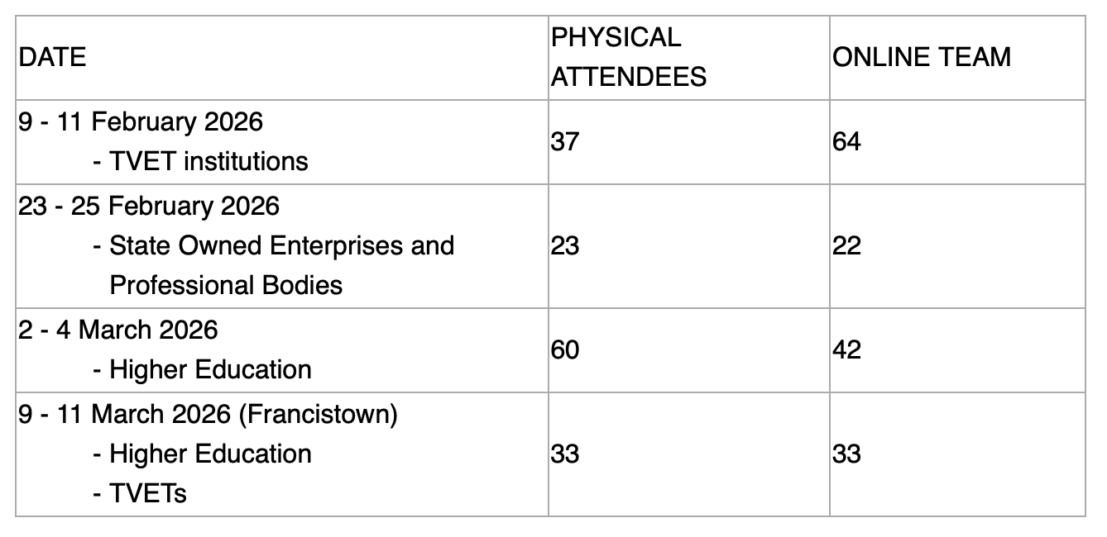
And for the last session, 16-18 March: 23 attendees + 7 BQA staff

In addition to the slides decks and the recommendations for the breakaway sessions, the conclusions of the different groups involved in the breakaway sessions are also appended to this report.

